Finance 334 - Mutual Fund Analysis -

Value Fund: Fidelity Series Stock Selector Large Cap Value F (FRGEX)

Pit Kauffmann, Tor Martinsen, Jordan Mucci, Adam Salow, Steve Toner

Fund Description:

The Fidelity Series Stock Selector Large Cap Value Fund Class F (FRGEX) follows a standard value strategy: the fund “seeks long-term growth of capital” by following a strategy of buying securities they believe to be undervalued on the basis of fundamentals and with respect to other companies in the same industry. In addition, it follows the strategy of “normally investing at least 80% of assets in stocks with… [market capitalizations] comparable to those in the Russell 1000 Index or the S&P 500.” FRGEX aims to keep its portfolio balanced across all GICS sectors, and has holdings in securities of both domestic and foreign firms.

Q1: FRGEX Market Capitalization

|  |  |
| --- | --- |
| **Mega (> 50B)** | 44.67 |
| **Large (10B to 50B)** | 37.20 |
| **Mid (2B to 10B)** | 13.60 |
| **Small (250MM to 2B)** | 0.95 |
| **Micro (< 250MM)** | 0.01 |

Russell 1000 Value Distribution

| Distribution | %Port | %Port Chg [6M] | Mkt Val (MM) | Mkt Val Chg (MM) [6M] |
| --- | --- | --- | --- | --- |
| Mega | 50.5 | 1.53 | 12,986 | 748 |
| Large | 33.4 | -0.74 | 8,595 | 640 |
| Mid | 15.2 | -0.91 | 3,904 | 228 |
| Small | 0.6 | -0.12 | 147 | 13 |
| Unassigned | 0.4 | 0.25 | 108 | 69 |
| Micro | 0.0 | -0.00 | 0 | 0 |
| **Total** | **100.0** | **-0.00** | **25,740** | **1,696** |

Compare to: Russell 1000 Index, and S&P500 by market capitalizations

As a large-cap fund, one would expect that the majority of the portfolio is invested in stocks with a market capitalization between $10 and $50 billion; however, as we see from the table above, FRGEX is only37.2% invested in companies of this size. The bulk of its holdings fall into Mega-cap stocks, but this allocation likely reflects the fact that the fund uses the Russell 1000 Value Index as its benchmark; because the Russell indices have a much wider range for each capitalization class, it gives the managers more liberty to invest in mega-cap stocks than the S&P 500 classification.

Q2: Fund Managers

Six managers are responsible for the oversight of FRGEX:

* Mutual Fund Managers:

Matt H Friedman since 12/6/2012

John Mirshekari since 12/6/2012

Justin J Bennett since 12/6/2012

Katherine Buck since 12/6/2012

Laurie M Mundt since 12/6/2012

Steve S Barwikowski since 12/6/2012

At first glance, it doesn’t appear to raise any red flags - All have experience managing mutual funds at financial institutions, and they have all had experience with value-style funds.

Q3: Financial Ratios

|  |  |
| --- | --- |
| Avg P/E Ratio | 25.35 |
| Avg P/B Ratio | 2.53 |
| Avg Div Yld (%) | 2.45 |
| Avg Sales Growth (%) | -2.47 |
| Price Momentum | 1.03 |
| Relative Strength | 7.78 |
| Beta | 0.95 |

The most alarming of the above ratios is the incredibly high average Price/Earnings ratio of 25.35. As a self-proclaimed “value” fund, FRGEX has no reason to hold so many stocks with a high enough P/E ratio that the average P/E for the entire fund is as high as 25.35. Even if this average reflects the bias of one extremely overvalued security, it still reflects a serious departure from the fund’s stated investment strategy. The much lower average P/B ratio for FRGEX suggests that the majority of the fund’s managers pay much more attention to P/B as a metric for screening undervalued securities than Price/Earnings, the latter of which is arguably the more robust measure.

On the other hand, the fund’s low Relative Strength index of 7.78 is a good sign that FRGEX is buying predominantly stocks that are oversold, yet one would expect that the managers would have chosen stocks primarily based on measurements of a stock’s value, rather than a momentum metric such as Relative Strength.

Q4: Global Distribution of Asset Allocation

|  |  |
| --- | --- |
| North America | 88.55 |
| Europe | 7.84 |
| Latin America | 0.05 |
| Asia | 0.00 |

The majority of FRGEX’s investments are in North American firms, with about 8% of its holdings in Europe. As these foreign investments only make up a small portion of the fund’s assets, one can expect that currency risk will not be a large component of the fund’s overall risk. However, this still represents a substantial difference in allocation relative to the fund’s benchmark (Russell 1000 Value), which is almost entirely invested in domestic securities.

Q5: Morningstar Rating

The Morningstar rating is four stars, which appears high given the past performance of FRGEX. However, the Morningstar rating system ranks funds relative to funds with similar investment styles and weights based on the funds’ recent history, so it is quite likely that FRGEX has still outperformed other Large-cap Value funds, even though the strategy in general has been underperforming.

Q6: Appropriate Benchmark

FRGEX lists the Russell 1000 Value ETF as its benchmark, and conducting a risk decomposition in Barra confirms that this benchmark results in an incredibly low active risk of 1.76%. Furthermore, the Russell 1000 Value ETF has almost identical sector allocation weights, making the comparison of FRGEX to its benchmark even more straightforward. Indeed, it appears that the managers of FRGEX are working diligently to mirror the composition of their benchmark as closely as possible, as can be seen in the tables below.

|  |  |
| --- | --- |
| Benchmark | Active Risk |
| Ishares Core S&P Small - Cap | 6.49% |
| Russell 1000 | 3.50% |
| Russell 1000 Value | 1.76% |
| Russell 2000 | 6.89% |
| S&P 500 | 3.76% |
| S & P Midcap 400 | 4.70% |

6. Benchmark - Russell 1000 Value TR USD

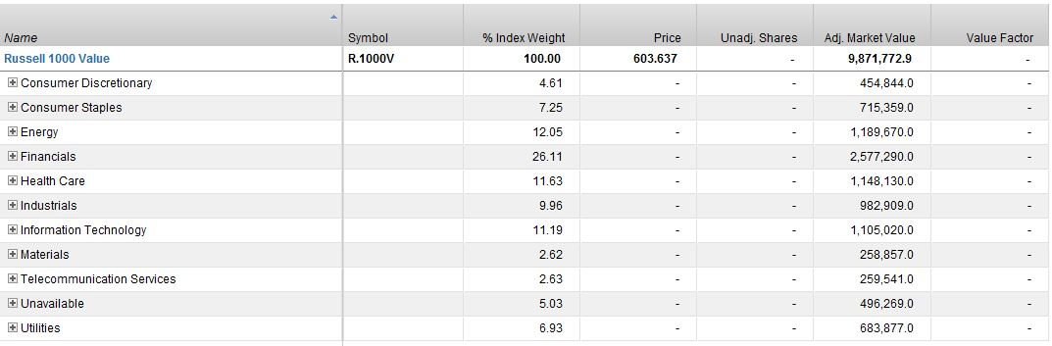

Sector Weights for FGREX

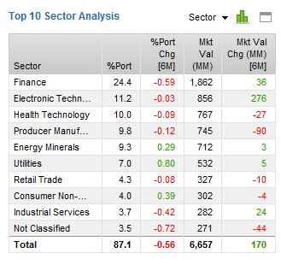

Sector Weights Russell 1000 Value

| Sector | %Port | %Port Chg [6M] | Mkt Val (MM) | Mkt Val Chg (MM) [6M] |
| --- | --- | --- | --- | --- |
| Finance | 25.4 | -2.52 | 6,529 | 473 |
| Health Technology | 10.5 | 0.55 | 2,694 | 154 |
| Energy Minerals | 9.9 | 0.10 | 2,558 | 149 |
| Producer Manufacturing | 9.4 | 0.57 | 2,409 | 83 |
| Electronic Technology | 8.1 | -0.38 | 2,075 | 215 |
| Utilities | 7.2 | 0.66 | 1,849 | 115 |
| Consumer Non-Durables | 5.2 | 0.49 | 1,340 | 77 |
| Technology Services | 4.3 | 0.40 | 1,103 | 72 |
| Industrial Services | 3.2 | -0.29 | 815 | 49 |
| Retail Trade | 3.0 | -0.06 | 779 | 41 |
| **Total** | **86.1** | **-0.48** | **22,151** | **1,429** |

Q7. What are the 1, 3, and 5 year returns for the benchmark?

The 1, 3, and 5 year returns for the Russell 1000 Value were -1.54%, 9.38%, and 10.25%, respectively.

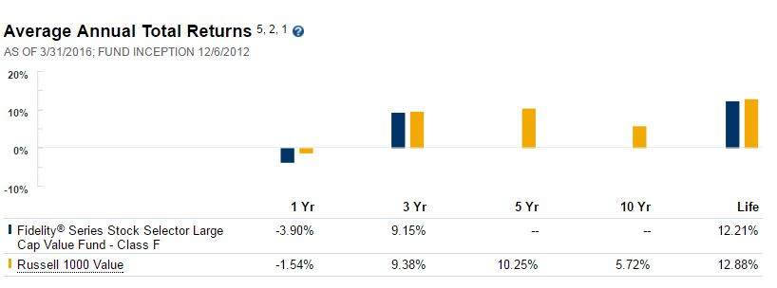

Q8. What are the 1, 3, and 5 year returns for the fund?

The 1 and 3 year returns for FRGEX were -3.9% and 9.15%; because the fund started in 2012, it is just shy of having 5 years of historical data, but we can see that the fund has consistently underperformed relative to its benchmark since its inception.

Q9. **What is the Active Risk of the fund?** The appropriate benchmark is the IShares Russell 1000 Value ETF, which results in the lowest active risk of 1.75%. 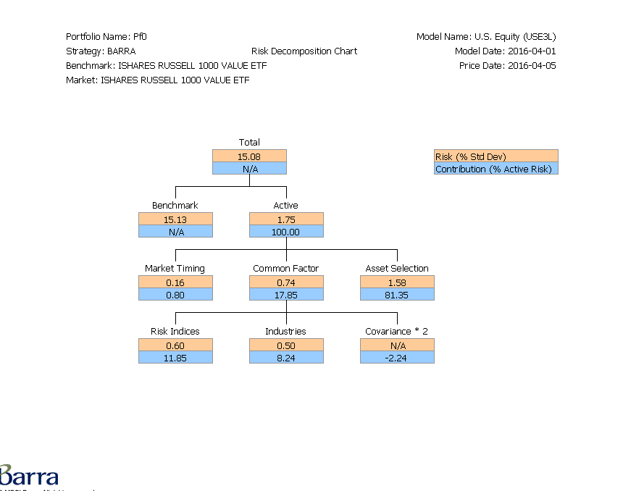

**Q10. What ‘type’ of fund is it?**

Compared to the typical range of active risk expected for Value funds, this is very low (active risk for Value funds ranges between 3 and 6%), suggesting that this fund is not offering a great enough return for Value-style investors’ preferences. With this level of active risk, FRGEX is less of a Value style fund and more of a “tilt” fund.

**Q11. What % is the common factor risk and how does it break down into “Industries” and “Risk Indices”?**

The common factor risk for FRGEX accounts for 17.85% of the total active risk of the fund, 8.24% coming from Industries and 11.85% coming from Risk Indices; the difference is made up by a reduction in overall risk coming from the Covariance of the stocks in the portfolio, which is -2.24% of the Active risk. In general, all of these numbers indicate that the fund managers are extremely concerned with managing and lowering risk for their investors -- so much so, that they no longer have the risk exposure that is customary for their investment style. It may very well be that their 3-year lag in performance relative to the Russell 1000 ETF is due to the fund managers systematically making allocation decisions that are too risk-averse, and as a result their returns have suffered.

**Q12. What does the Barra sector exposure look like? Express Comments and Concerns**

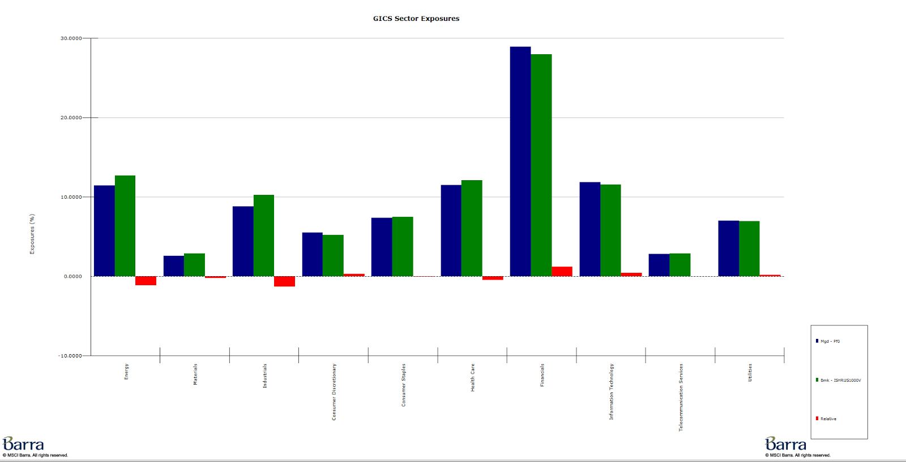

Mimics the sector distribution of the benchmark very closely. Because FRGEX is a “Stock Selector” fund, this makes sense – any risk that the fund adds to an investor’s portfolio should come primarily stock selection, not sector bets.

**Q13. What does the Barra style risk exposure look like? Express Comments and Concerns**

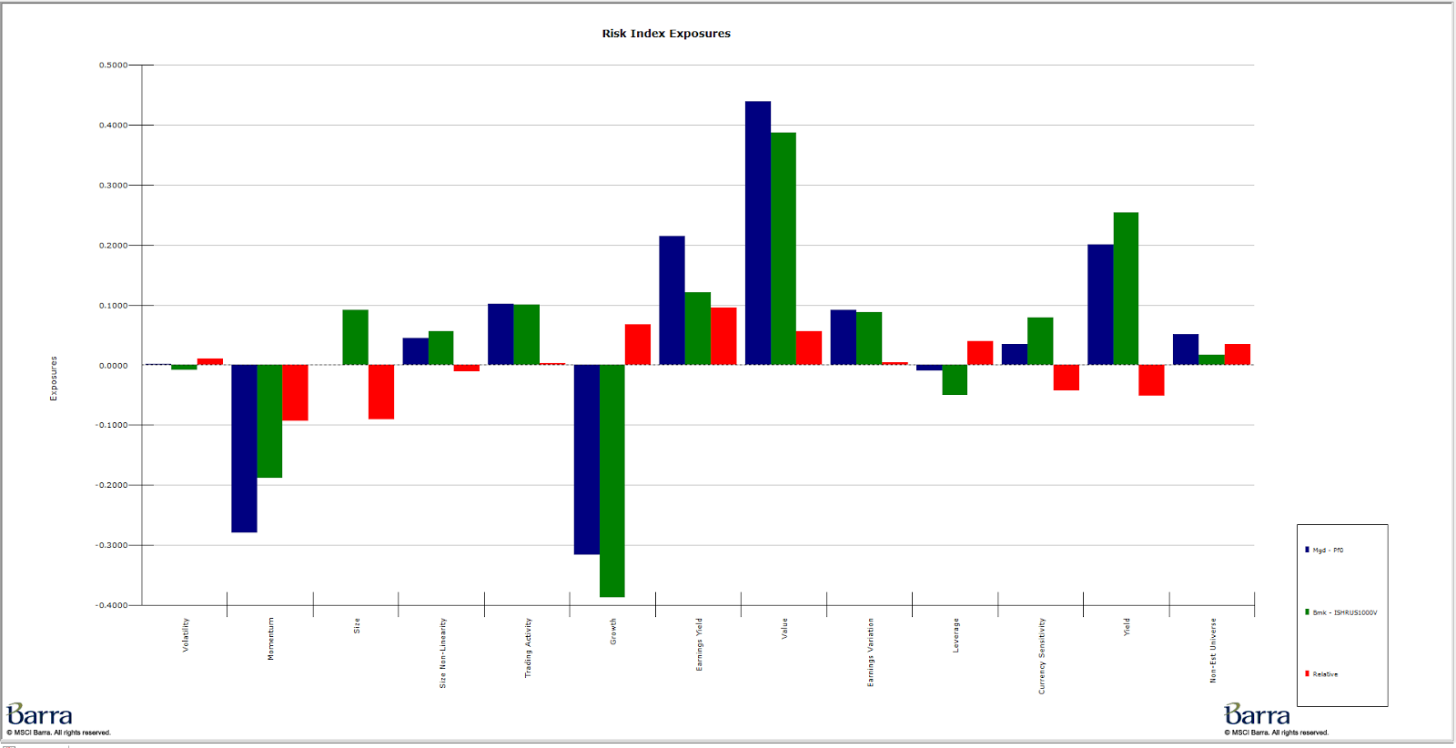

The style risk exposure of FRGEX has greater departures from the benchmark, which for the most part tend to be in the right places for a fund of this style – the relative underweighting in momentum and overweighting in value and earnings yield are consistent with the fund’s Value strategy. At the same time, the fund’s relative underexposure to size risk doesn’t make much sense for a large-cap fund.

**Q14. What stocks add the most risk?**

|  |  |  |  |  |  |
| --- | --- | --- | --- | --- | --- |
| **Least Diversifying** | | **MC to risk** | **%weight** | **Q SCORE** | **Sector** |
| **CRC** | **CALIFORNIA RES CORP** | **0.086** | **0.13** | **6.94** | **Energy** |
| **NXPI** | **NXP SEMICONDUCTORS N V** | **0.081** | **1.04** | **5.27** | **Information Technology** |
| **KMI** | **KINDER MORGAN INC DEL** | **0.078** | **0.73** | **6.53** | **Energy** |
| **MU** | **MICRON TECHNOLOGY INC** | **0.067** | **0.41** | **5.44** | **Information Technology** |
| **SGY** | **STONE ENERGY CORP** | **0.066** | **0.01** | **NA** | **Energy** |
| **WDC** | **WESTERN DIGITAL CORP** | **0.062** | **0.61** | **5.22** | **Information Technology** |
| **QCOM** | **QUALCOMM INC** | **0.06** | **2.17** | **5.14** | **Information Technology** |
| **CVX** | **CHEVRON CORP NEW** | **0.058** | **5.15** | **6.19** | **Energy** |
| **APC** | **ANADARKO PETE CORP** | **0.054** | **0.98** | **6.72** | **Energy** |
| **CIT** | **CIT GROUP INC** | **0.053** | **0.73** | **4.05** | **Financials** |

**Q15. What stocks add the most style risk?**

|  |  |  |  |  |  |
| --- | --- | --- | --- | --- | --- |
| Least Diversifying | | MC to risk | %weight | Q SCORE | Sector |
| CRC | CALIFORNIA RES CORP | 0.086 | 0.13 | 6.94 | Energy |
| NXPI | NXP SEMICONDUCTORS N V | 0.081 | 1.04 | 5.27 | Information Technology |
| KMI | KINDER MORGAN INC DEL | 0.078 | 0.73 | 6.53 | Energy |
| MU | MICRON TECHNOLOGY INC | 0.067 | 0.41 | 5.44 | Information Technology |
| SGY | STONE ENERGY CORP | 0.066 | 0.01 | NA | Energy |
| WDC | WESTERN DIGITAL CORP | 0.062 | 0.61 | 5.22 | Information Technology |
| QCOM | QUALCOMM INC | 0.06 | 2.17 | 5.14 | Information Technology |
| CVX | CHEVRON CORP NEW | 0.058 | 5.15 | 6.19 | Energy |
| APC | ANADARKO PETE CORP | 0.054 | 0.98 | 6.72 | Energy |
| CIT | CIT GROUP INC | 0.053 | 0.73 | 4.05 | Financials |

**Q16. What stocks add the most sector risk?**

|  |  |  |  |  |  |
| --- | --- | --- | --- | --- | --- |
| Least Diversifying | | MC to risk | %weight | Q SCORE | Sector |
| CRC | CALIFORNIA RES CORP | 0.086 | 0.13 | 6.94 | Energy |
| NXPI | NXP SEMICONDUCTORS N V | 0.081 | 1.04 | 5.27 | Information Technology |
| KMI | KINDER MORGAN INC DEL | 0.078 | 0.73 | 6.53 | Energy |
| MU | MICRON TECHNOLOGY INC | 0.067 | 0.41 | 5.44 | Information Technology |
| SGY | STONE ENERGY CORP | 0.066 | 0.01 | NA | Energy |
| WDC | WESTERN DIGITAL CORP | 0.062 | 0.61 | 5.22 | Information Technology |
| QCOM | QUALCOMM INC | 0.06 | 2.17 | 5.14 | Information Technology |
| CVX | CHEVRON CORP NEW | 0.058 | 5.15 | 6.19 | Energy |
| APC | ANADARKO PETE CORP | 0.054 | 0.98 | 6.72 | Energy |
| CIT | CIT GROUP INC | 0.053 | 0.73 | 4.05 | Financials |

**Q17. Sell one stock that has a lot of sector risk. Replace the stock with a new appropriate**

**stock. Explain why you sold the stock and why you added the other stock.**

Sell: MXIM (Maxim Integrated products)

Reasons:

For starters, MXIM simply isn’t a value stock, with 60.62 PE, and long term book to price ratio of 10.9. In addition, of the contributors to sector risk, it had the most negative quant alpha as predicted by the US master quant screen.

Buy: AVT (Avnet)

To keep our sector risk exposure the same, we want to swap the stock with another IT stock. From the US Master quant screen we see that AVT is also an IT stock and has a good quant score of 4. Furthermore, the stock is a better value pick, with a lower PE for an IT stock of 10.62. Finally, the stock has a good dividend yield and only a moderate level of debt, which gives us confidence that it isn’t a value trap.

**Q18. Sell one stock that has a lot of style risk. Replace the stock with a new appropriate stock. Explain why you sold the stock and why you added the other stock.**

Sell: CRC (California Resource Group)

CRC is not large cap stock with a market cap of $504 million, in addition to it having the second largest contribution to style risk and a high quant score of 6.94 on the US Master screen. Further research showed that the company has a dangerously high debt to equity ratio of 272.4, in addition to an incredibly large short interest as a percent of float.

BUY: TSO (Tesoro Corporation)

TSO is a much better pick for FRGEX for several reasons: while still being in the same sector, it has a better quant score of 4.92, and a moderate PE of 12. In addition, it is actually a large cap stock, which is more consistent with the fund’s proclaimed investment strategy.

**Q19. Sell one stock that is inappropriate/”out of place”/”does not belong” in the fund. Replace the stock with a new stock. Explain why you sold the stock and why you added the other stock.**

Sell: SGY – Stone Energy Corp.

Why FRGEX holds SGY is a complete mystery – it isn’t really a value stock with a value score of -2.84 in Barra, and it isn’t a large cap stock either with a $39.23 million market capitalization.

The icing on the cake is that it doesn’t have an available number for its PE ratio because the company has been logging losses for so long.

Buy: VLO – Valero Energy Corp.

Valero is a better fit because it’s market capitalization of $29.62 billion fits the fund’s investment style, and it doesn’t affect sector allocations because it is also an energy stock. VLO is a good value play because of its good quant score of 4.55, and a lower PE ratio of 7.90 trailing, 8.56 forward

**Q20. Does the fund manager hold the stock that “seems out of place”, in their other funds?**

Yes, John Mirshekari’s Fidelity Value Fund, Fidelity Low Priced Stock Fund, and others all hold SGY, but Factset and LinkedIn provide no further insight into any possible connections he may have to the company

**21. What is the information ratio for the fund?**

The information ratio for FRGEX is -1.35, which is terrible. Much of this poor performance is due to unusually poor returns in the past year, but the fund’s low level of active risk allows for little negative deviation from the fund’s benchmark performance before the information ratio plummets.

**22. Would you provide a salary increase for the fund manager? Why or why not?**

I would not provide a salary increase for the fund manager, because although they didn’t do anything grossly irresponsible, they didn’t do much at all in terms of providing value for their clients. Because the majority of the fund’s active risk comes from stock selection, it reflects only the work of the individual fund managers who picked the stock, making it difficult for one to pin the fund’s poor performance on anyone but the managers. Because the fund underperformed as well as misrepresented itself as a value fund when it is really a value tilted index, a salary increase for the fund manager would be entirely unwarranted.